The proximity highlighter was off in the first test for picking up, dropping, and rotating the material on screen. For the next test to shortlist the material, the proximity highlighter was on. For the third test, to toggle lights off and on, the proximity highlighter was off again.

In the second test, the UI screen for the shortlist was only on when the user approached the object, and the button UI for lights was static on the screen.

These A/B testing methods improvised to  understand how participants perceive proximity and vicinity in VR.

**Testing Insights**

**Participant Observations**

Participant 1 - Doro  
It was easier for her to move around once she realized she had to press ESC to get back the pointer. She picked up on interactions quickly. She looked at the UI on the keyboard for mouse right-click and then easily rotated the object. Testing with the shortlist was easy, and she moved easily, but she did not understand what "shortlist" meant. She assumed both materials were the same because they had similar descriptive UI screens.

Participant 2 - Aditya  
He found navigation easy and intuitively used the right click to rotate. He noticed the object turning yellow when he was closer, making it easier to click and rotate. He understood that the shortlist on the screen referred to the yellow-highlighted item. He liked the transparency effect for looking around. However, he was unsure when he was close to other objects. For the third test, when the button was static on the screen, he expected the light toggle to affect only the closest object, but was surprised to see it worked for all.

Participant 3  
She was a bit confused when moving in the 3D world. Picking up and dropping materials was not easy. For the shortlist test, she noticed that proximity color was the same for two close objects and assumed it would be nicer if different colors or gradients indicated proximity levels. She pointed out that the UI showed near the proximity area was helpful. She said the lights-on/off button was always on screen regardless of proximity and thought it would control lights for all materials.

Participant 4  
She quickly picked up controller movements but struggled with rotating the object. She kept trying to rotate objects as she would in the real world, like in a shop. For the first test, the proximity highlighter was off, which confused her about when to use the mouse to pick up objects. For the shortlisting test, she found it easier to understand when the color changed. She understood the different UIs for different screens and assumed materials with the same shortlist button might be similar. She demonstrated an understanding of similarities in the virtual world.

Participant 5  
Participant 5 showed a keen interest in exploring the prototype but initially struggled with managing object interactions, particularly the rotation function. Once familiar with the controls, the participant was able to manipulate objects more fluidly. They appreciated the visual feedback from the proximity highlighter, which helped in understanding item selection. The shortlist feature was clear after some explanation, but the participant suggested adding more descriptive labels to differentiate shortlisted materials. For lighting controls, they expected individual control per item and found the global toggle confusing. Overall, Participant 5 expressed satisfaction with the usability but recommended additional onboarding guidance to smooth the learning curve.

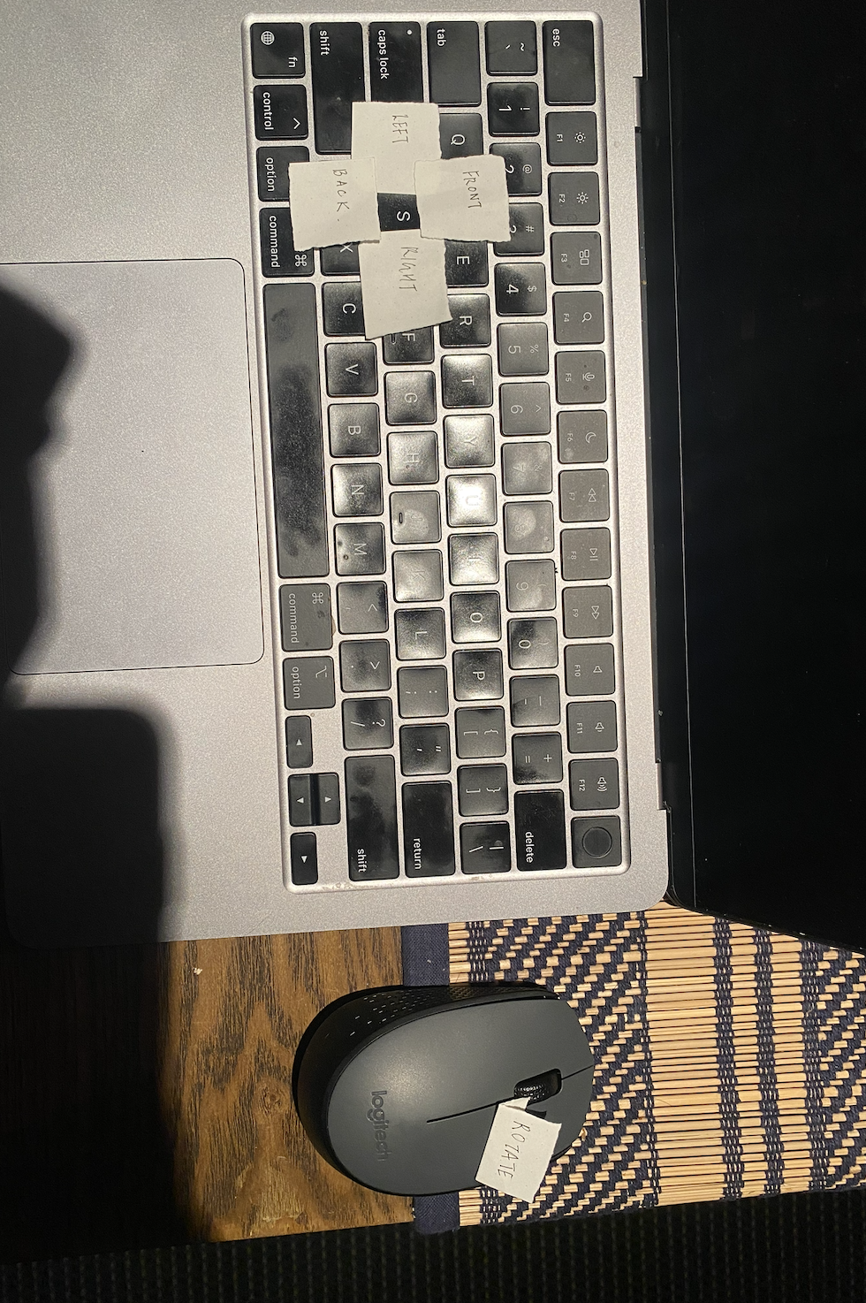

Figure Before Testing Source Author